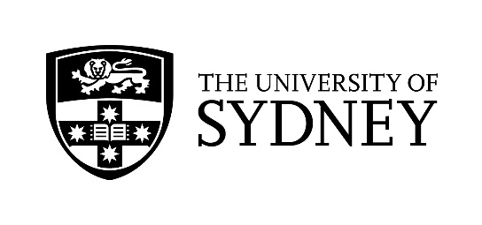

The University of Sydney’s E12 Scheme

From 2018 the University of Sydney’s E12 Scheme is being administered via UAC’s Schools Recommendations Schemes (SRS). This means that students wanting to apply for E12 must apply for SRS via the UAC website, and must upload this document, with answers to the questions below. Each answer must not exceed 200 words.
Please note: you will only be considered for entry under E12 for the top E12-eligible University of Sydney preference in your list of UAC preferences as at 11:59pm on 30 September 2019. That is, you will only be considered for one (1) course in terms of entry under E12.

Please enter your answers below, under each respective question. Then save and upload to your SRS application.

Each answer must not exceed 200 words.

1. Other than your regular schoolwork, consider activities you have been involved in, or achievements you have made, which are meaningful to you. These could be sports, cultural, community or school leadership activities. Select the one which best reflects you and describe why you undertook this activity, what you learned from it, and how it may be relevant to your future.
2. What are your three best academic achievements? Of these, select your proudest achievement and describe why it is important to you, describing the challenges you faced and how you overcame them.
3. Tell us why you want to study the course you have chosen, (include any experience you may have had that relates to this course). What is your interest in this area and what do you hope to achieve from studying this course?

