Suggested Social Media Post Wording

I’m lacing up for Boot Bash
Just 2 in 5 students supported by the Country Education Foundation of Australia in 2023 received financial support from the Government.
Rural and regional students have a harder hike to education success, we need to help bridge the gap between regional and metropolitan youth completing post- school education.
That’s why I’m lacing up in my favourite boots for CEF’s Boot Bash on Friday 15th March to kick it for education equality. Together we can raise awareness and funds to support CEF students kick their goals.
Time to kick it up a notch and join me in spreading the word about the Boot Bash:
Wear your favourite boots for the ‘Boot Bash’
Post photos on social media using the hashtags #CEFBootBash and #kickingitforeducationequality
Get your university, school or workplace involved by encouraging them to host a ’Boot Bash’ event.
To find out more about the ‘Boot Bash’ go to https://cef.org.au/boot-bash/
#CEFBootBash #kickinitforeducationequality #CEF #countryeducation #regionalaustralia #makeitpossible

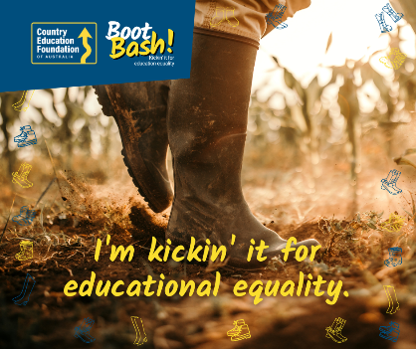
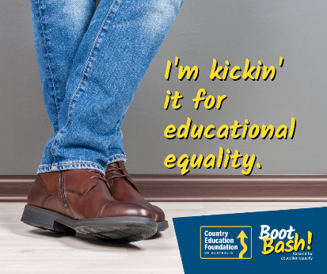
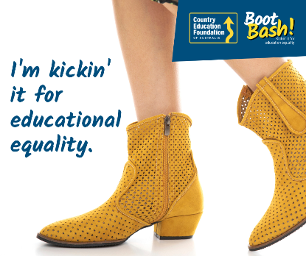
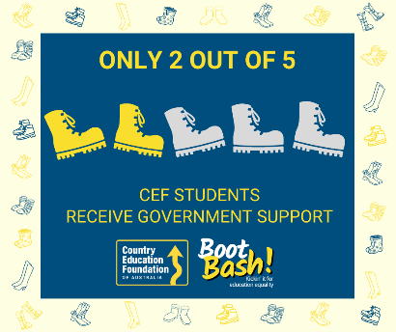
Goes with these social media tiles:

Help CEF students kickstart their year
Living away from home to study is tough, and we know last year 79% of CEF supported students had to move away to study. And guess what? 60% used their grants to help with rent!
CEF is closing the gap between regional and metro students, making sure we all have equal access to education and employment opportunities.
On Friday 15th March, join in on the CEF’s Boot Bash. Help make a difference by spreading awareness, donating, or hosting a Boot Bash event. Let’s give our students the support they deserve!
Find out more here https://cef.org.au/boot-bash/
#CEFBootBash #kickinitforeducationequality #CEF #countryeducation #regionalaustralia #makeitpossible

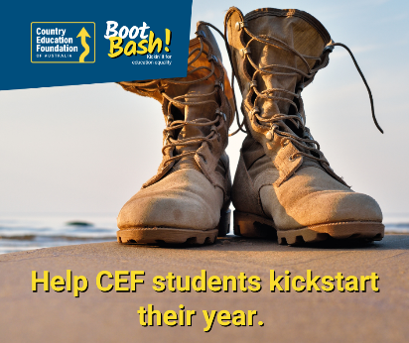
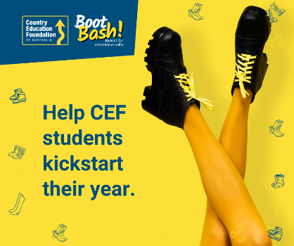
Goes with these social media tiles:

Impact/give cost-of-living the boot
📣Calling all rural and regional students! The cost-of-living struggle is REAL, but we're not giving up! 💪💥
Fuel prices are skyrocketing ⛽, making it tough for 79% of CEF-supported students that need to leave home to study to pursue their dreams. 🏡🎓
Between September 2022 and September 2023, the price of fuel increased by 19.7%.
Let's stand together on March 15th for the 'Boot Bash' 🥾 and give these warriors the support they need!
Spread the word, donate, or host an event. Let's make education accessible for all! 🚗✨
Find out more here https://cef.org.au/boot-bash/
#CEFBootBash #kickinitforeducationequality #CEF #countryeducation #regionalaustralia #makeitpossible

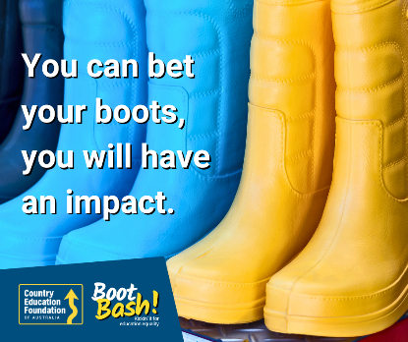
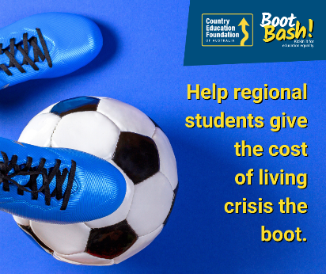
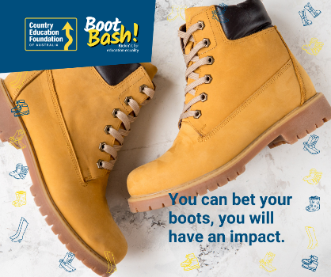
Goes with these social media tiles:

For more information:
Ph: (02) 6362 3162
Email: info@cef.org.au

